20MCA136 – NETWORKING & SYSTEM ADMINISTRATION LAB Dept. of Computer Applications

|  |
| --- |
| **Name: VYSHNAV SURESH**  **Roll No: 56**  **Batch: B**  **Date: 09-05-2022** |

**NETWORKING & SYSTEM ADMINISTRATION LAB**

**Experiment No.: 15**

**Aim**

Write a shell script to find sum of first 10 numbers.

**Program**

echo "enter the limit" read n

sum=0

for (( i=0;i<=n;i++ )) do

sum=$((sum + i))

done

echo "the sum of the entered number is " $sum

# Output screenshot

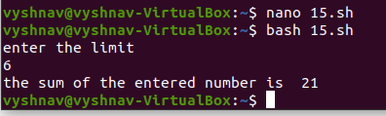

Amal Jyothi College of Engineering, Kanjirappally